**LAB SESSION 05**

* **4-BIT PARALEL ADDER CIRCUIT:**

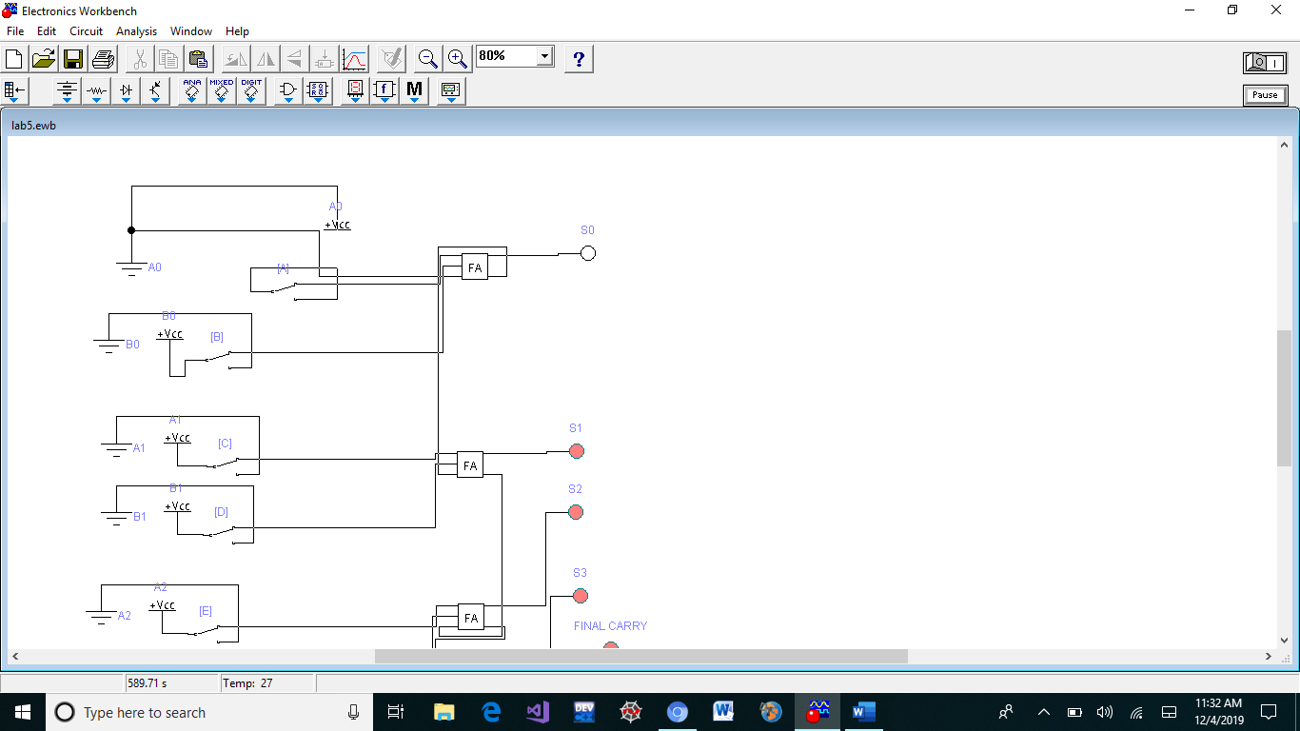

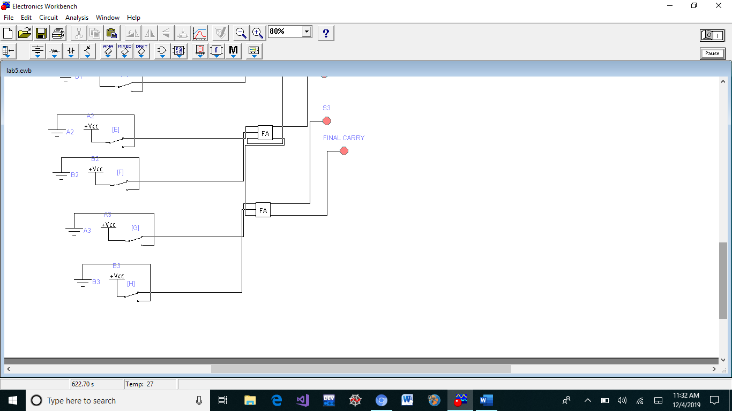

* **SUB CIRCUIT :**

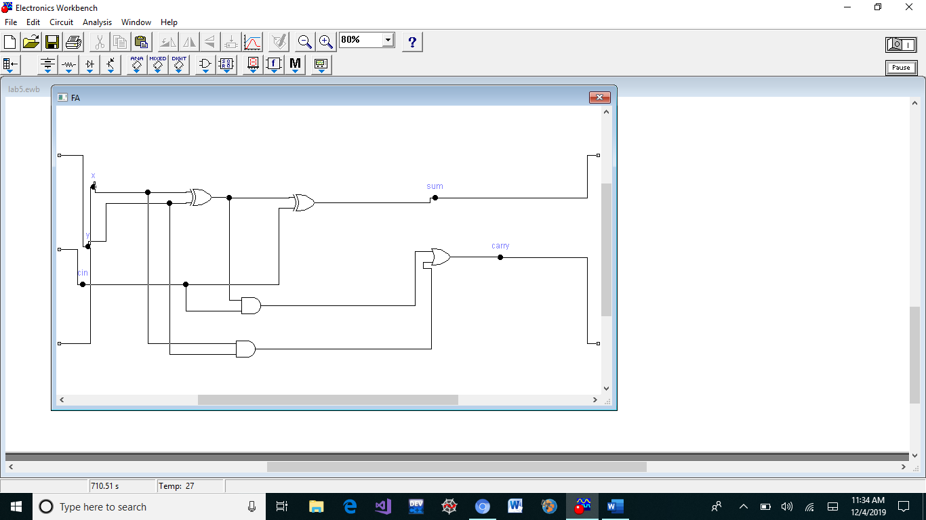

* **2’s COMPLEMENT ADDER AND SUBSTRACTOR CIRCUIT:**

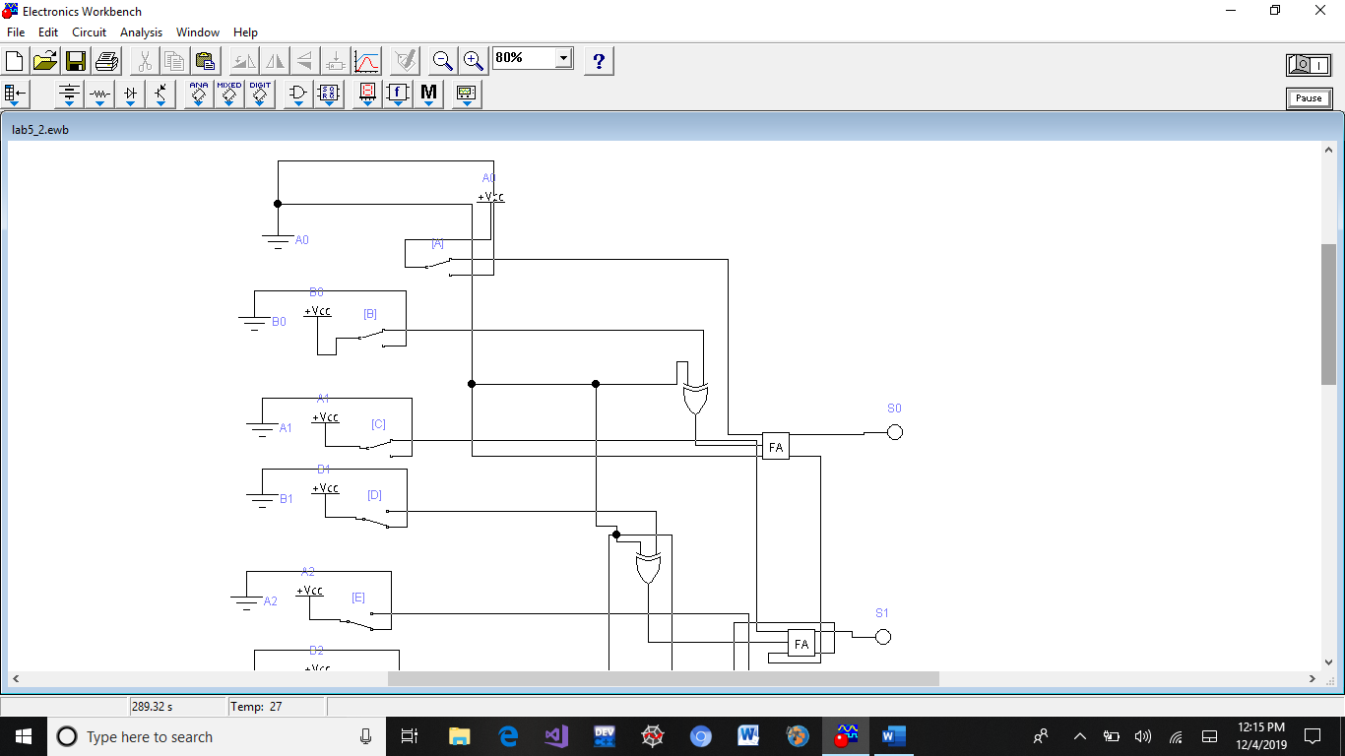

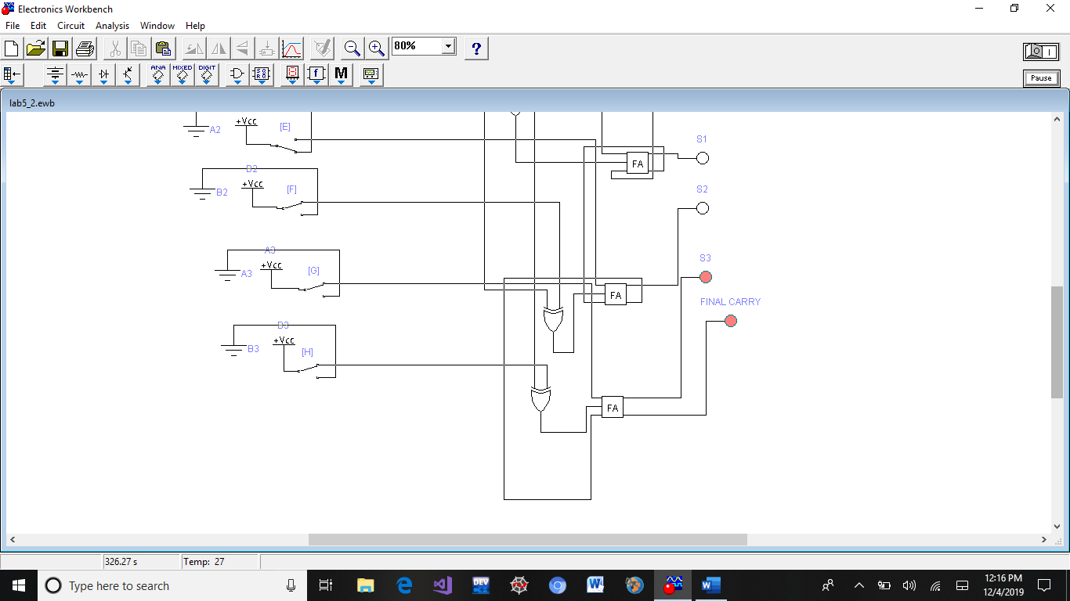

* **Prepared by Muhammad Faraz Ansar (SE-061)**